Closure of requisitions via workflow tasks
Users can now close a requisition which is no longer needed via one of 3 existing workflow tasks
Rejected Requisition
Supplier required
Price required
A new “Close Requisition” task is initiated to the originator of the requisition– Users MUST change the status from Active to CLOSED before saving
The option to amend and resubmit is still available
Rejected Requisition task
New “Close Requisition” option available
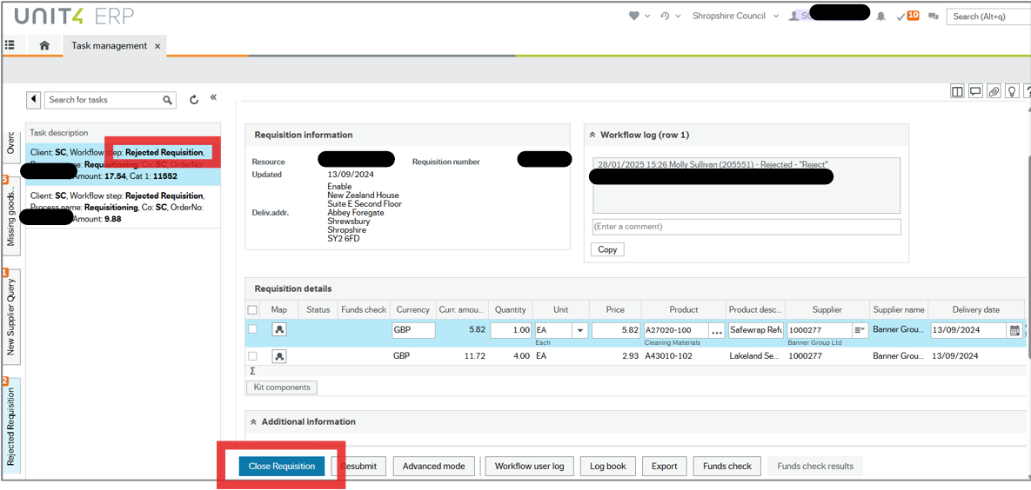
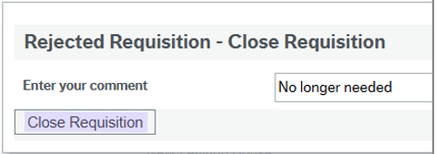
The new “Close Requisition” task will appear with status as Active but users MUST change this to CLOSED before saving
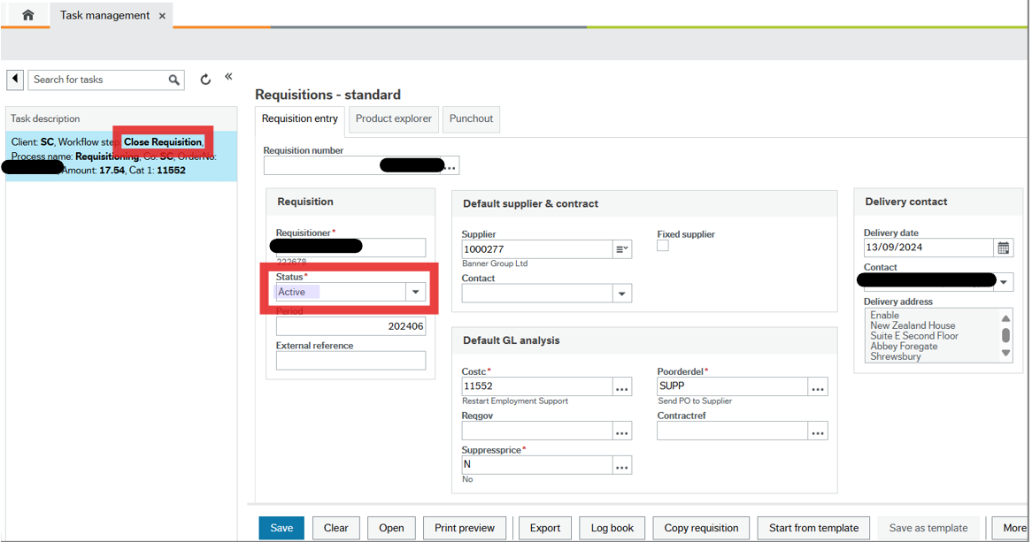
Status changed to “Closed”
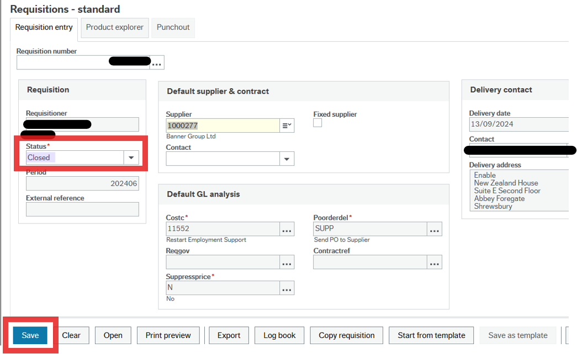

Supplier required task
New option to “Close requisition”
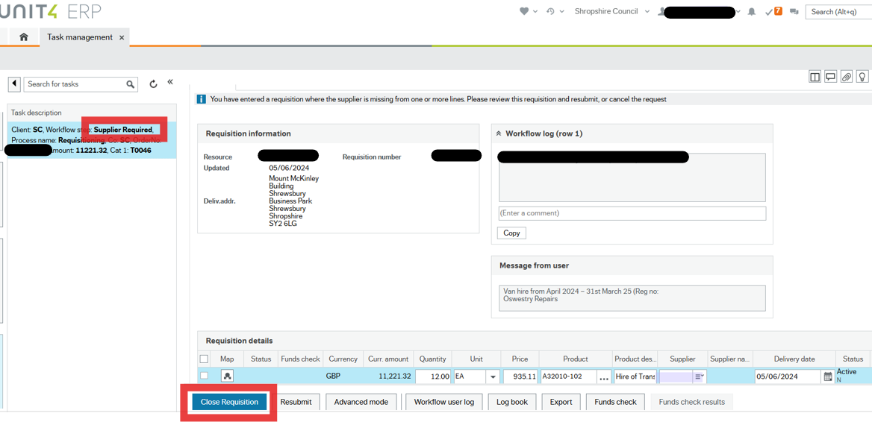
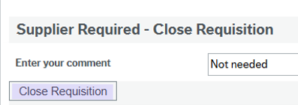
New “Close requisition” task initiated
User MUST change status from active to Closed before clicking Save
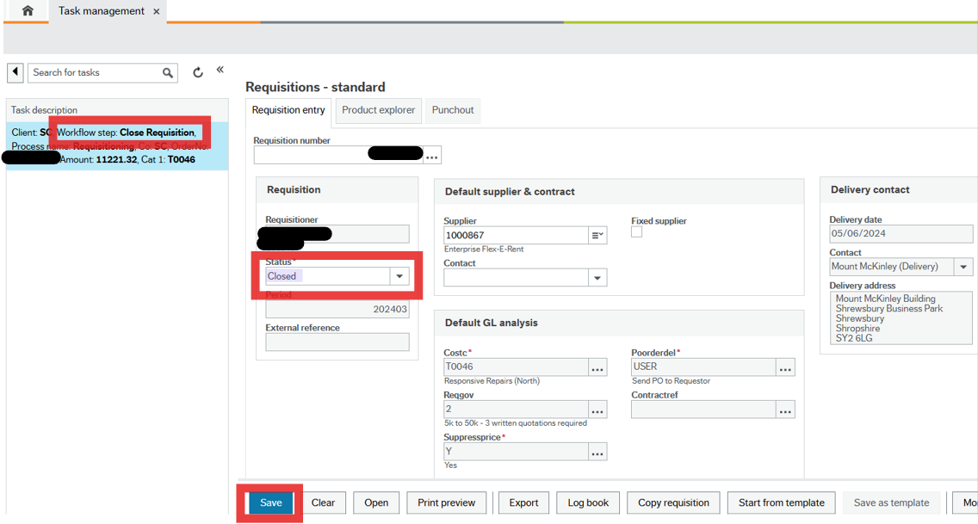

Price Required task
New “Close Requisition” option available
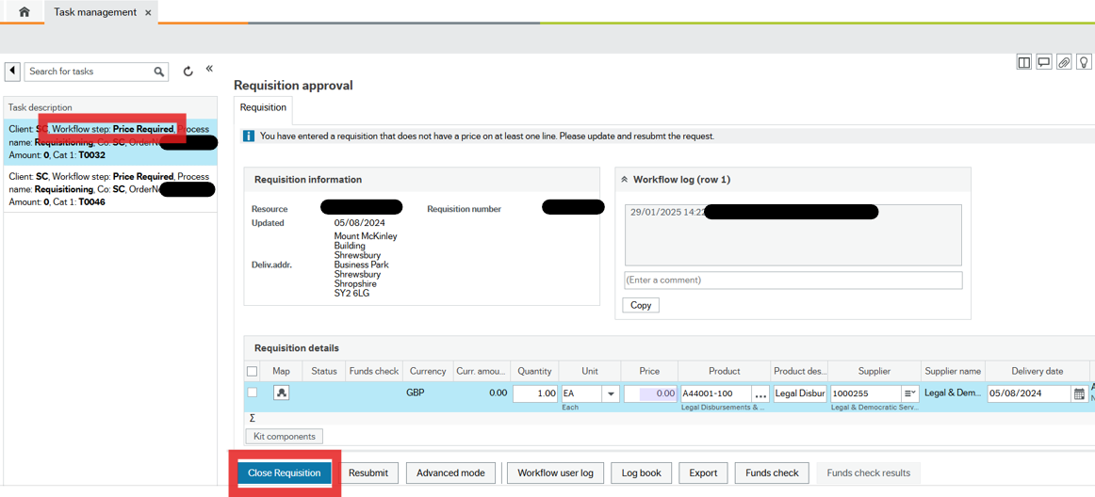
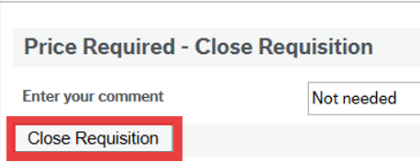
User MUST change status from active to CLOSED before clicking Save
