**P2P Invoice Status Enquiry**

You can check where an order is the workflow and when the invoice is due to be paid by going into the P2P Invoice Status Enquiry under Common Reports on the dashboard.

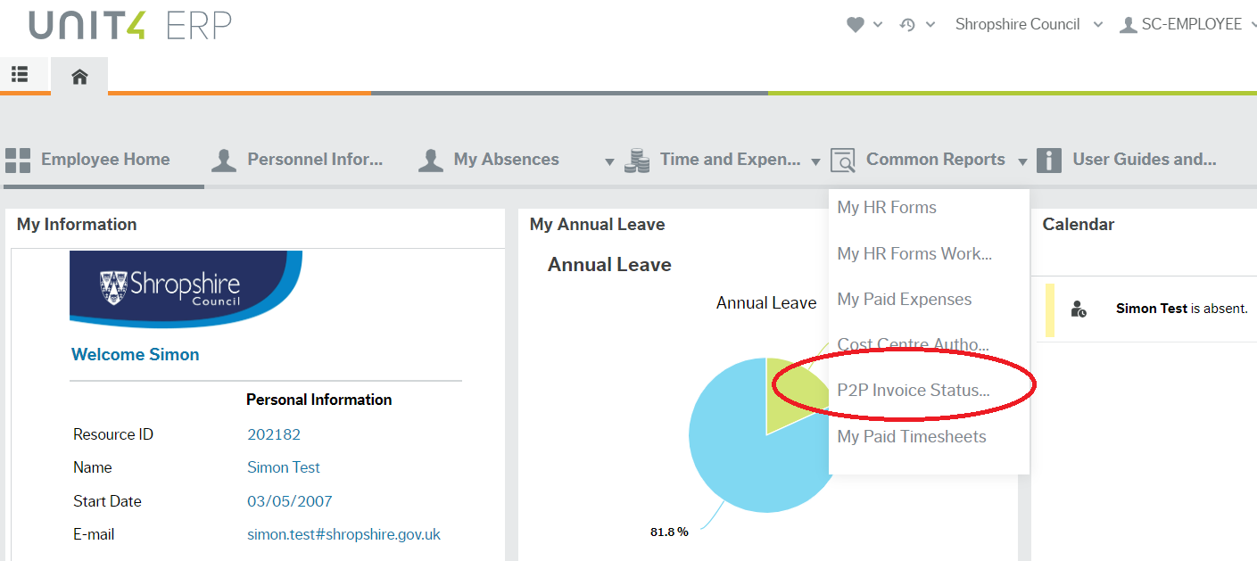

You can check by Supplier if you put in the SuppID in that field and click search, it will bring up all the orders for that Supplier. If you need to look up Supplier ID, this can be done under Procurement > Supplier information > Suppliers. In the Lookup box, type ahead can be used to type the supplier name to identify the supplier ID.

You can also filter by Cost Code or the order number (see below)

Put the Order Number in and click Search:

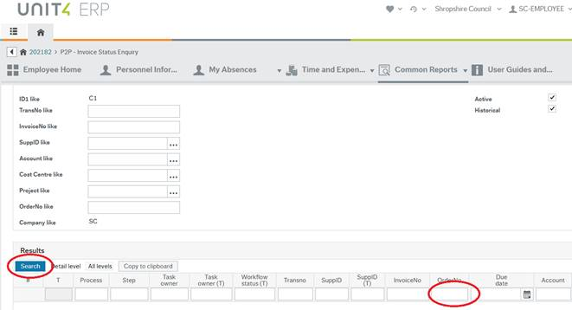

You can then scroll across and select Open and Historic to view the payment date:

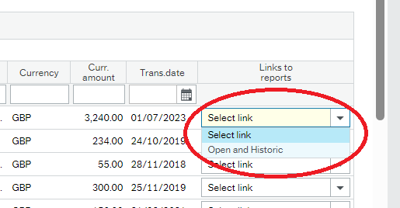

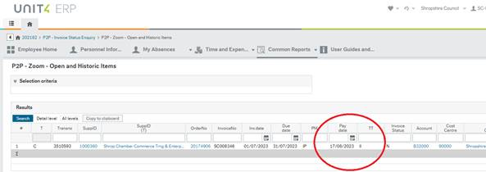

If there isn’t a payment due date, then the invoice hasn’t been received by Proactis yet.

The status of your invoice is shown in the T column on the enquiry page.

If the Status is A – This means that the invoice is in workflow and requires further action before it will be paid.

If the Status is B – This means the invoice is finished in workflow and is either ready for payment or has been paid (N.B. invoices that have been paid (C – Paid), will still appear as status B, you will need to look under Open & Historic items to check payment as above.)