Mandatory Relation - Publish Spend
The relation - Publish spend has now become a mandatory field on ERP.
Which means whenever a new supplier is created or a supplier amendment is done, it will require a relation value against the Publish spend line as shown below.
There are 3 options to choose from when entering the Relation Value, please see below the options & the guidance behind each option to help you make the correct selection
C- Commercial Redacted - commercially sensitive data – data that would, or would be likely to, prejudice the commercial interest of any legal person by impacting their ability to participate competitively in a commercial activity
N- Not Redacted – none of the other 2
P- Personally Redacted - personal information, for example, payments to individuals for adoption and fostering, care related payments, refunds and compensation payments. This does not include payments to sole traders.
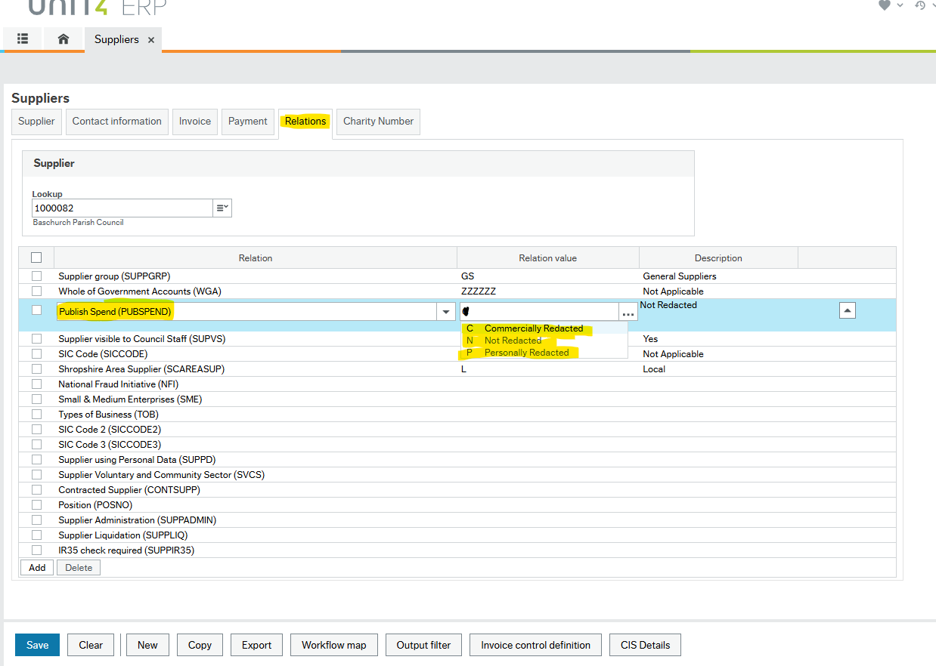
If you need any further guidance on making the choice for this relation, please contact Nicola.higgins@shropshire.gov.uk

