Incident Form – Authorisation

If you are a school’s authoriser, then you will receive a task through Business World when someone at your school reports an incident on Business World. You will need to click on the “LM Approval” task to access the completed form.
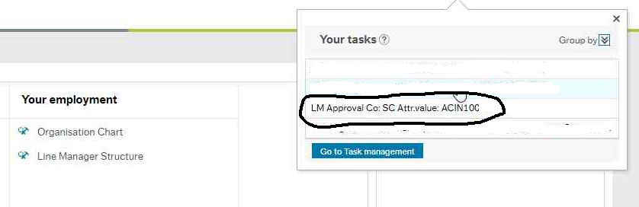

If you are a school’s authoriser and you are completing the incident details on the form, you will also need to complete the authorisation tab before submitting the form. This role has been assigned to you by the headteacher and it is their responsibility to make sure you have the authority to do this.
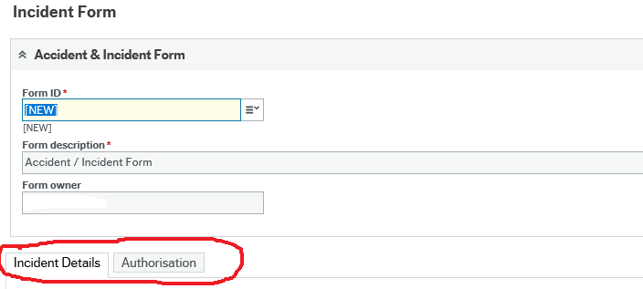

Once you have accessed the form, please check through all details on the “Incident Details” tab and then click on the “Authorisation” tab.
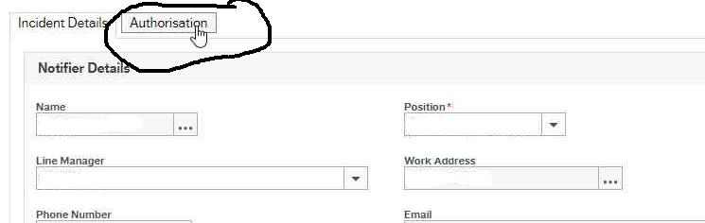

Make sure you add a comment in the “Further Details” box even if it is just to confirm that no further action is needed.
Also make sure you answer “Yes” to the authorisation statement to confirm that you have read through and agree with the incident details otherwise the form will be sent back to you.
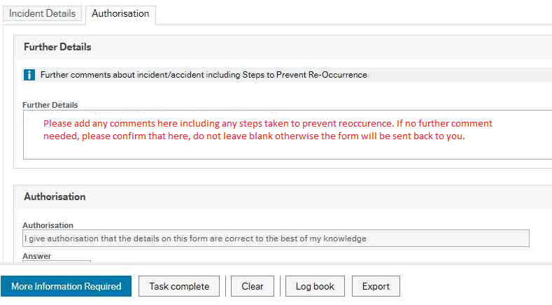

Once you are happy that all details are correct and it is ready to come through to the Heath & Safety team, then you can click “Approve”.
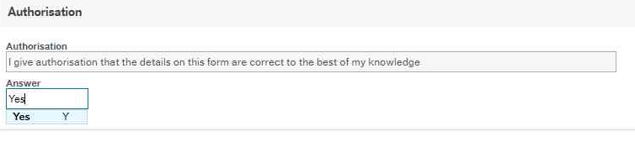
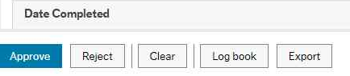
If you are not happy that the form has been completed correctly or with enough detail, you need to “Reject” the form so it will workflow back to the initial notifier.
Before clicking “Reject”, you need to add a comment to the workflow log stating what needs amending or adding.
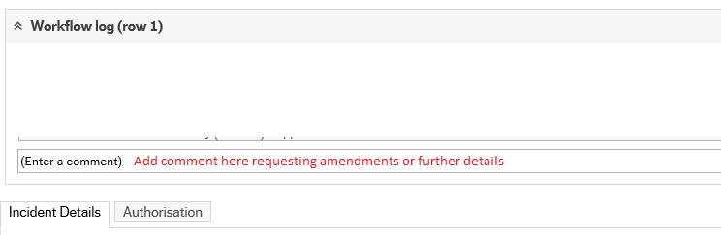
Once you have added the request for more information, you can click “Reject” and the form will go back to the notifier.
