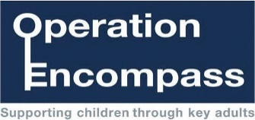
Op Encompass Record of referral
Today’s date
SCHOOL:

Child’s name and DoB:

Date of incident:

Police reference number

*** Please note that schools are still expected to follow the usual Shropshire Safeguarding reporting procedures via F.P.O.C. alongside OE notifications. ***
This form is not a replacement for the process outlined above.

Additional information:
.
There is no expectation to reply to this OE alert UNLESS you have relevant information to share within the daily Domestic Abuse Triage.

If this is the case, please email compass.referrals@shropshire.gov.uk with an email title of “FAO Domestic Abuse Triage” by 10.45am.

Please DO NOT send this information to the Domestic Abuse Education Coordinator

For school use Comments for DA Triage.
Email to compass.referrals@shropshire.gov.uk
Completed by Date:

