How do I view invoices in the system?

To view the image and status of your invoice in Unit4 Business World, once you log into the system you can go to Reports > P2P > P2P – Invoice Status Enquiry

This will direct you to an enquiry page in the system and you will then have a range of options by which you can search for your invoice.
In the example below I have typed in the invoice number and then clicked on the search button and all of the possible results have been returned. You could also search by Supplier ID, Supplier Name, transaction number, your Cost Centre or Account Code (subjective) if required.

How do I view the Invoice Image?
You can scroll to the right hand side of the page and then click on the transaction number of the invoice which is highlighted in blue

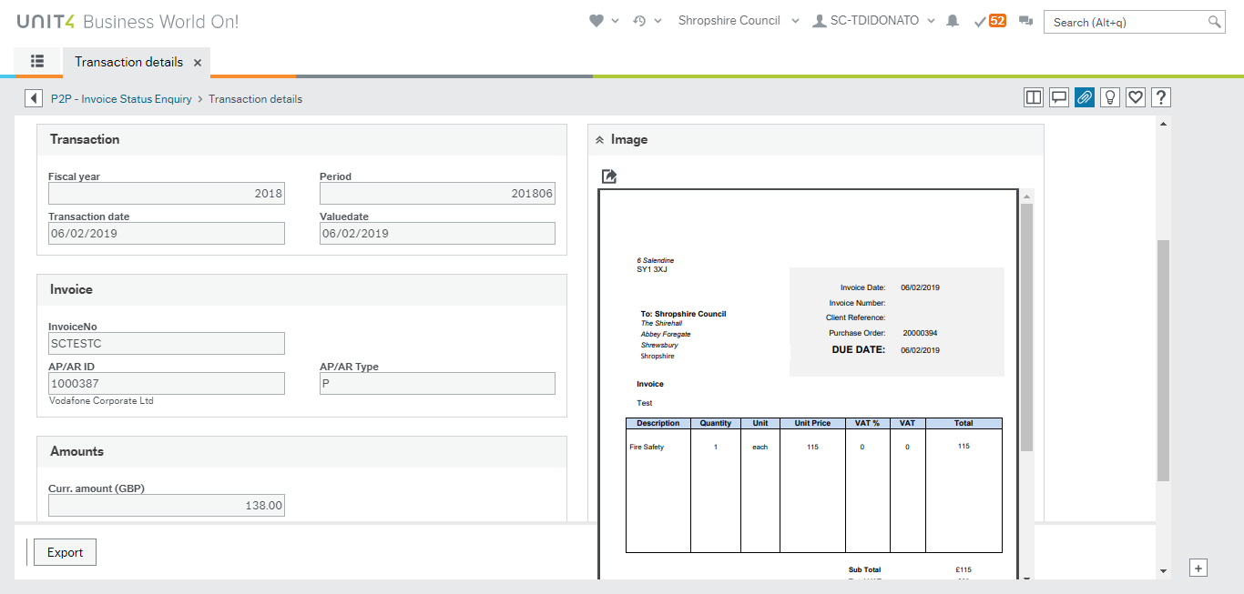

How do I know if my Invoice has been paid to the Supplier?
The key to understanding the status of your invoice is shown in the T column on the enquiry page.
If the Status is A – This means that the invoice is in workflow and requires further action before it will be paid
If the Status is B – This means the invoice is finished in workflow and is either ready for payment or has been paid.

In the example above, because the Status is A, you can click on the ‘Workflow in Progress’ section and this will display a workflow map and show you who the invoice is with to complete further action.

After reviewing the workflow map, you will then be able to liaise with the person that the invoice is with and ask them to take appropriate action to get the invoice paid.

If the Invoice shows as a B status, you can scroll to the right of the screen and on the Link to reports section you can then click on the drop down and the click on Open and Historic.

This will then direct you to the payments page and you will be able to see the due date on the invoice and whether the invoice has been paid or not. If the invoice has been paid it will show as a C status.

