

Unit 4 ERP

FINANCE REVIEW GUIDANCE & ERP REPORTING FOR SCHOOLS

Revised by Schools Finance Team, Learning & Skills Jan 2024

Contents:

- Introduction & Audit page 2

- Logging on page 2

- Account Code List page 3

- GL Enquiry School Budget Holder page 5
- Service Area I&E page 8
- Reports: Budget Monitoring Report page 13
Payroll page 16
- House keeping – Cancel/Close Orders page 17
- Coding supply and additional hours page 21
- Splitting a Post between cost centres page 22
- Internal Recharge Account Code Guidance page 23
- Summary of financial reports/menus available page 24

- Glossary of Terms page 25

- Useful Contacts & resources page 26

Introduction & Audit
Regular monitoring of income and expenditure against the agreed budget is central to effective financial management. By reviewing the current position, necessary action can be taken to address overspends, shortfalls in income or allocate additional funding which has been received in year.

Schools should have a robust system in place to demonstrate that their financial transactions are being checked regularly and managed appropriately. It is recommended that regular checks should take place at least monthly. This Guidance is intended to assist and streamline that checking and budget monitoring process.

Appropriate management controls should be in place to manage the budget. You may be asked by Governors or Internal Audit to demonstrate how you do this. These management controls should include:
i) there is a system in place to download and save financial information on a regular basis – best practice would be each month once the accounting period has closed (April/May and August/September can be done together if need be)
ii) the transactions have been reviewed, demonstrated by your comments and actions in the appropriate column(s) and
iii) there is evidence that financial information is being reported regularly to Governors and this is reconciled to the accounting system (i.e. there is a clear trail between system reports and the information reported to Governors).

Any enquiry screen within the accounting system can be downloaded into an Excel spreadsheet and edited and sorted. This manual concentrates on the GL Enquiry, I&E, BMR & Payroll Reports. These are the recommended areas of the budget for schools to scrutinise regularly.

There is no requirement for the information on these excel downloads to be printed off and manually authorised.

Logging On
To access UNIT 4 ERP, you can use the link below:
https://ubw.unit4cloud.com/uk_sh1_prod_web

If the above link does not work, please use copy and paste.Your username will be your registered email address previously used in MyView. Your password is in the format of your National Insurance Number with your year of birth e.g. LLNNNNNNLYYYY
Guidance & support can be found on the Shropshire Learning Gateway here and here
Access or Permissions queries can be dealt with by emailing erp@shropshire.gov.uk

Account Code List - Allows user to view school account codes and their Consistent Financial Reporting relation. A full list of schools CFR account codes can be found on the Learning Gateway as follows - Consistent Financial Reporting (CFR) | Shropshire Learning Gateway (shropshirelg.net)

Ad hoc codes and to download your own list please follow these instructions –

To navigate: Reports>Global reports>Finance and Procurement>Finance>Account Code List

Enter a * in the Cfr2 column and then click Search for all account codes;

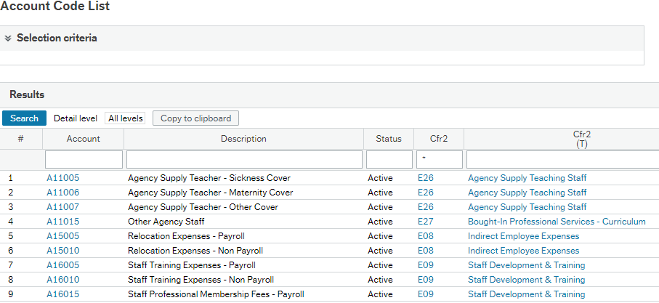

Or Search in the Description column using a * – for example;

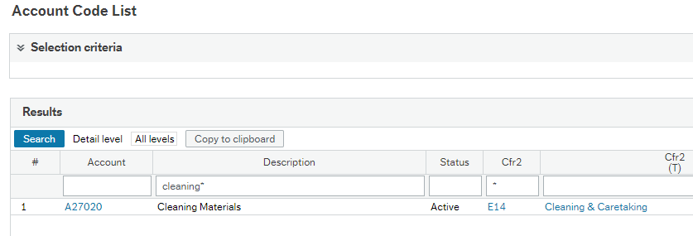

Schools can only use account codes which belong to a CFR (Consistent Financial Reporting) group.
All required account codes can be exported to excel to enable you to filter and sort, click on ‘Export’
Then click on Browser to open report in excel;

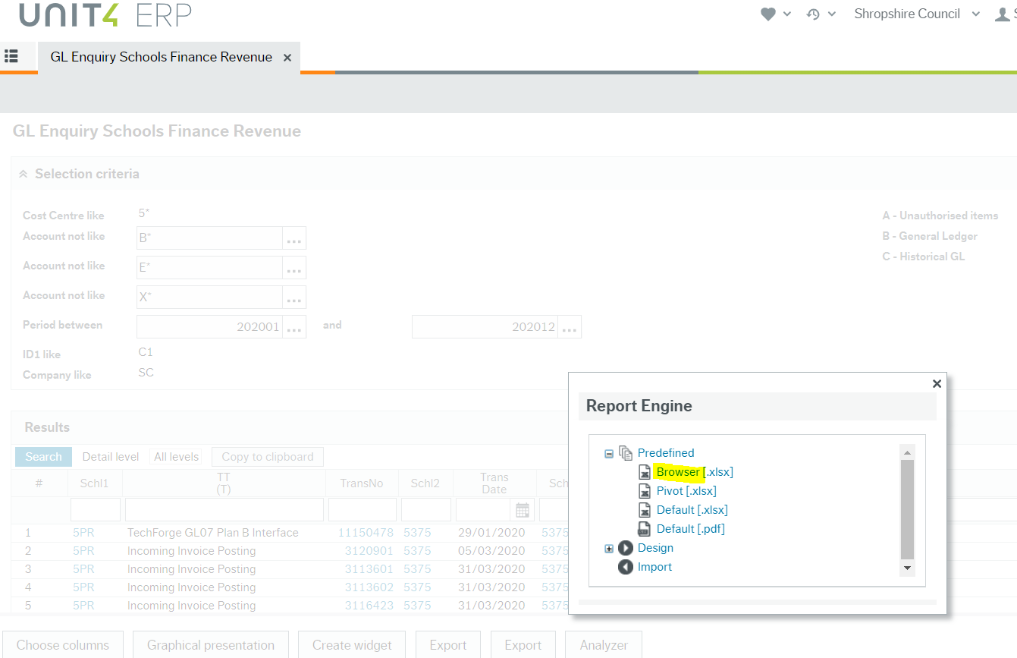
The excel report will display on your screen where you can select to open.

GL Enquiry School Budget Holder/ Cost Centre Subscriber GL Enquiry - The general ledger allows the user to review their actual spend to any chosen period, and will not show any commitments, enabling individual transactions to be monitored. It is recommended that transactions are reviewed at the end of every month (i.e. checking one month’s transactions at a time.)

To navigate: Reports -> Global reports -> Finance and Procurement -> Finance -> GL Enquiry School Budget Holder (or Cost Centre Subscriber GL Enquiry).

Once you have navigated to the report you can add to your favourites by clicking on the heart in the top right-hand corner.

A similar screen can be seen:
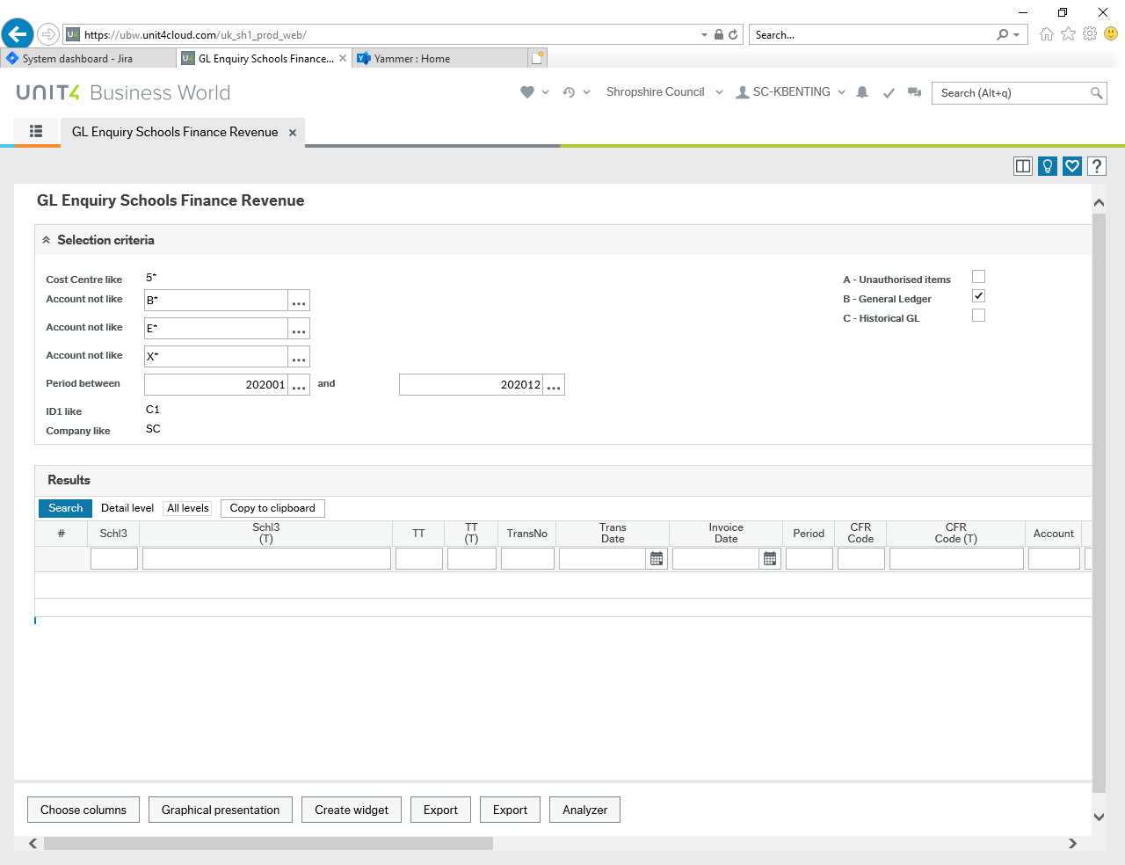

Enter the periods required and press search. It is recommended that you enter the previous full period. To check April’s transactions, enter 202001 and 202001 in both sections.
The first four digits relate to the financial year and the final two to the months, for example - 202001 = April 2020 and 202012 = March 2021. If you are running the report for the whole year – remember to choose 202013 so as to include period 13 which follows March prior to final closure of accounts.

You can filter by specific account codes/cost centres/Supplier or Customer IDs/Amounts etc. then press search again.

There is also an option to choose the columns on the report, you can use this to add or remove column relevant to your school:
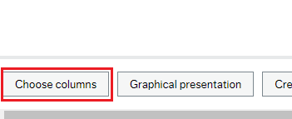

Results can be exported to excel by clicking on ‘Export’ to enable you to filter and sort. Then click on Browser to open report in excel. The excel report will display on your screen where you can select to open.

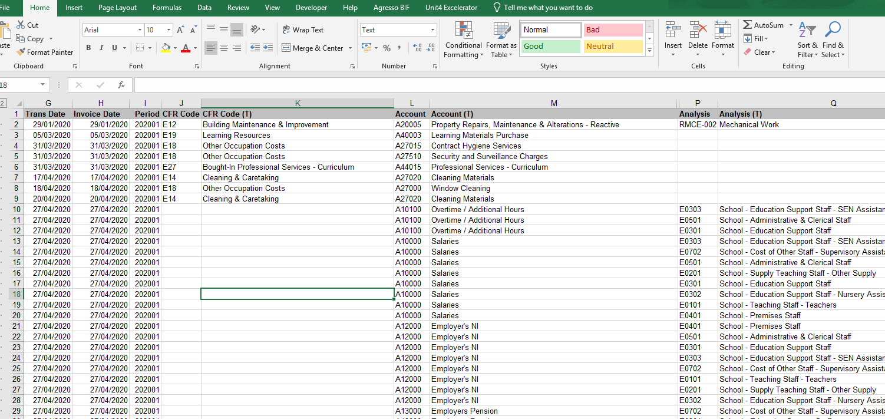

This GL Enquiry can also be used to interrogate a cost centre and account code and as follows;

Example below - entering the cost centre 50210 plus account code A4000* will bring through all paid trasactions paid from cost centre 50210 and account codes starting with A4000 such as A40000 Equipment purchase, A40001 Materials purchase, A40002 Learning equipment purchase and A40003 Learning materials purchase;

Remember to scroll left and click Search.

You can also drill down from each transaction to view the scanned invoice by clicking on the ‘TransNo’ in blue. You could then download the scanned invoice and save locally if needed.

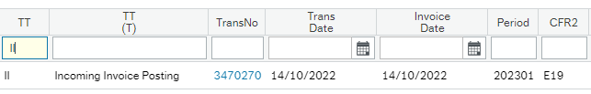

In addition the date of payment to a supplier can be found by scrolling right and clicking on the drop down field ‘Links to reports’

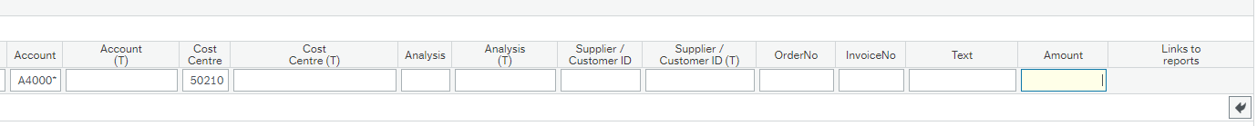Then by selecting ‘Payment Information.’ The next screen will show the ‘Pay date.’

Service Area Income & Expenditure - Gives an overview of budgets set against costs for each account code.
To navigate: Reports-> Finance &Procurement-> Finance-> Budget Monitoring & I&E -> Service area reports -> Service area schools I&E subscriber report
Once you have navigated to the report you can add to your favourites by clicking on the heart in the top right-hand corner.
A similar screen can be seen:

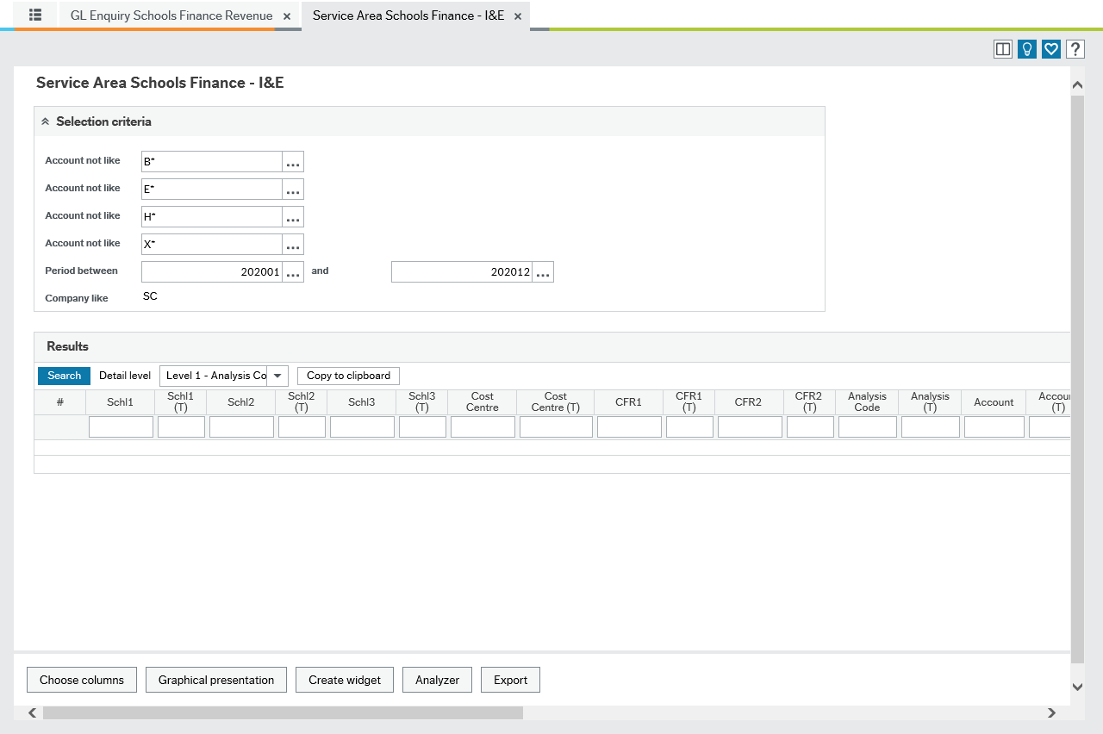
Enter the periods required. It is recommended that you use periods 202001 to 202013 to get a full year’s data. For monthly monitoring use the period to the end of the previous month, eg. If it is mid-march enter 202011 for all transactions to the end of February.
The first four digits relate to the financial year and the final two to the months for example - 202001 = April 2020 and 202012 = March 2021. If you are running the report for the whole year – remember to choose 202013 so as to include period 13 which follows March prior to final closure of accounts.

You can filter by a specific cost centres by entering the cost centre required in the cost centre field.

There is also an option to choose the columns on the report, you can use this to add or remove column relevent to your school:
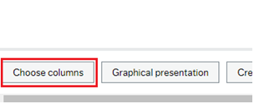

Once you are happy with the search criteria press the blue search button.

The report is subtotalled at each CFR code, as well as by expenditure and income.

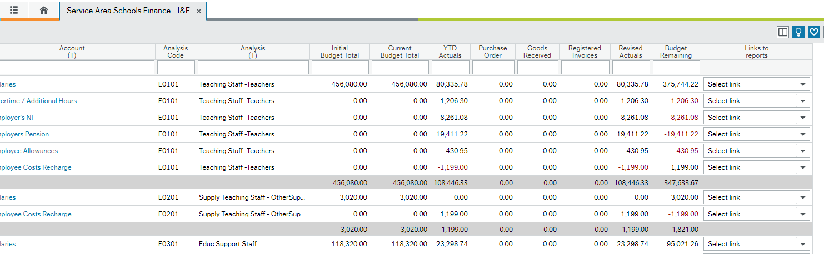

The report enables you to link to additional reports that give details of the data within the report.

Links are as follows:
YTD Actuals – Transactions that have gone through as of the date the report is produced.
Purchase Order- Goods that have been ordered but not received.
Goods Received- Goods that have been receipted, the amount authorised for payment.
Registered Invoices- All registered but unpaid invoices.

Revised Actuals – Shows all transactions as above added together.

Results can be exported to excel by clicking on ‘Export’ to enable you to filter and sort. Then click on Browser to open report in excel. The excel report will display on your screen where you can select to open.

You will need to click on the final number on the right side to open the details.

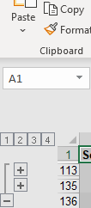

The Service Area Income & Expenditure can also be used to interrogate specific account codes and cost centres allowing users to see income and expenditure budgets and budget remaining as follows;

In this example by entering the required cost centre and account code you can see the initial budget (note that budgets are not uploaded to the system until agreed and signed off by governors and the head teacher during the summer term), current budget, YTD actuals (should match GL enquiry) plus any outstanding purchase orders, goods received and registered invoices which when added together gives the revised actuals and then the budget remaining. In this example the grounds maintenance (expenditure) budget is unspent as at the period selected by £142.81, so that is still left to spend before the end of the budget year or if unspent would be a year end budget saving.

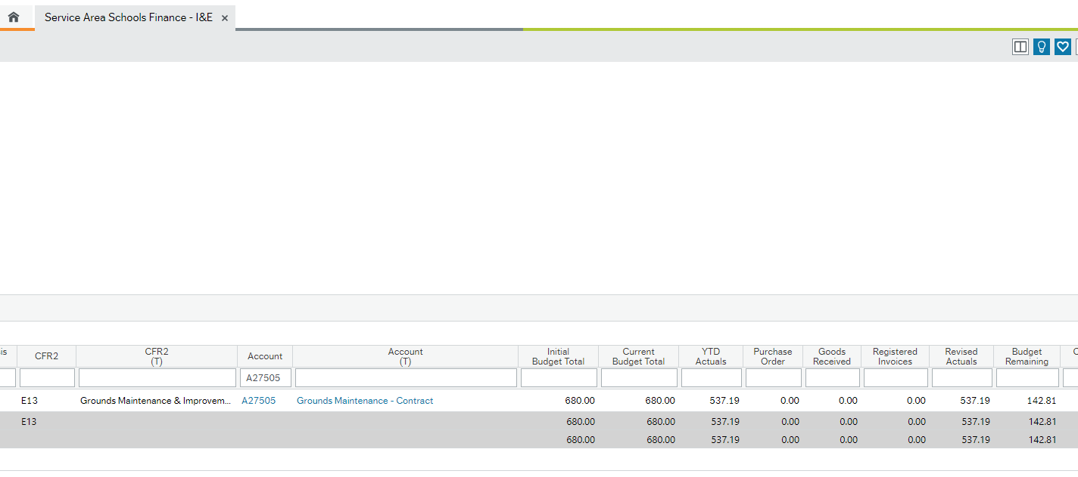

In this example by entering the required cost centre and account code you can see the initial budget, current budget, YTD actuals (should match GL enquiry) plus any outstanding purchase orders, goods received and registered invoices which when added together gives the revised actuals and then the budget remaining. In this example the pupil premium (income) budget has underacheived as at the period selected by £3,962.50, so that is still left to be received before the end of the budget year or would be an income shortfall if not received.

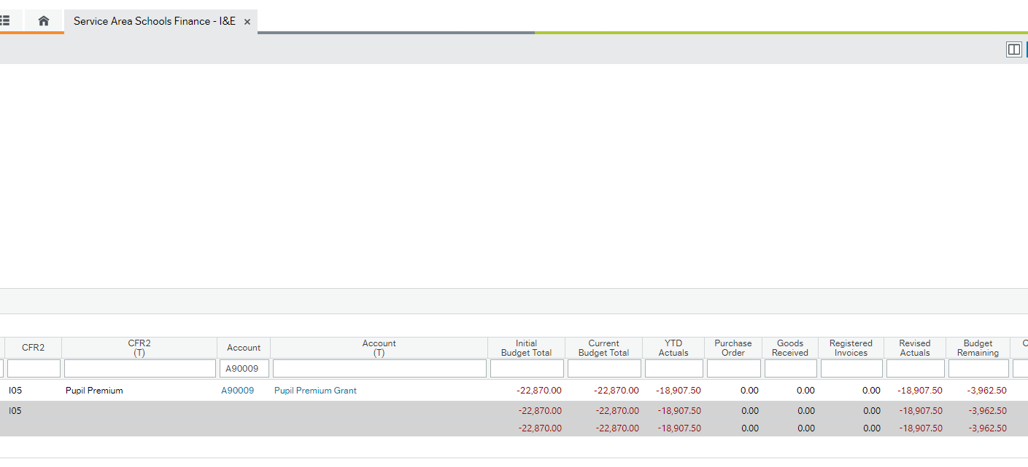

We also provide a transaction and budget monitoring report which has percentages and can be emailed to schools at the end of each month for an additional charge. For an example of this please contact your schools finance officer.

Schools Budget Monitoring Report/ School Subscriber Monitoring Report - Allows user to view schools monitoring position of all cost centres and view payroll data.

To navigate: Accounting -> General Ledger
A similar screen can be seen:
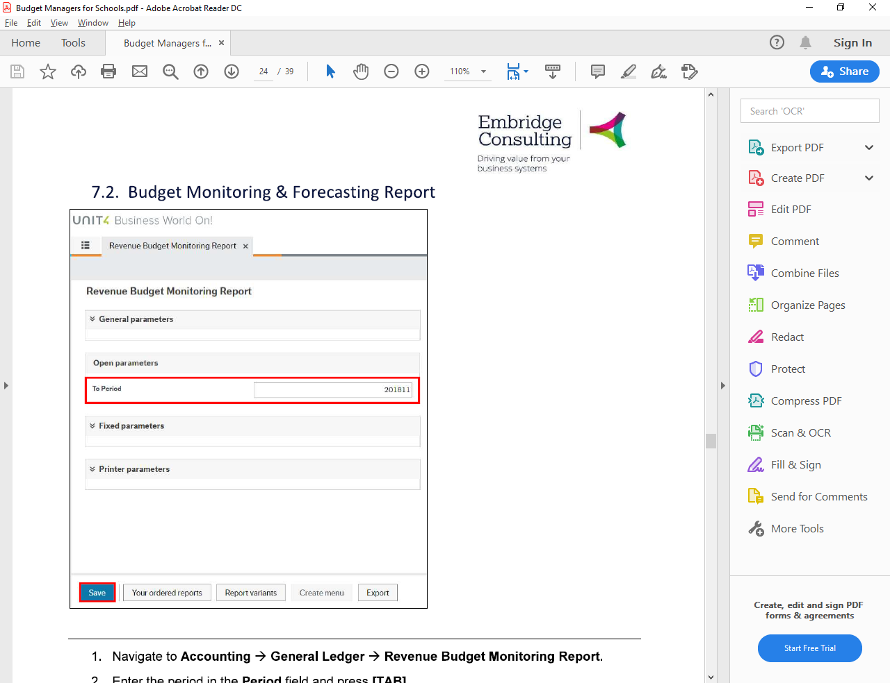
NB. The system knows who the user is, which is why you only have to ‘Save’

Click save. A success message should appear.
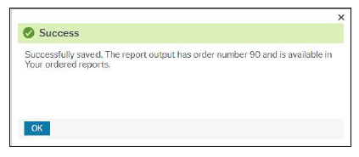

Click on your ordered reports at the bottom of the screen:

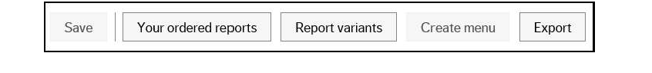

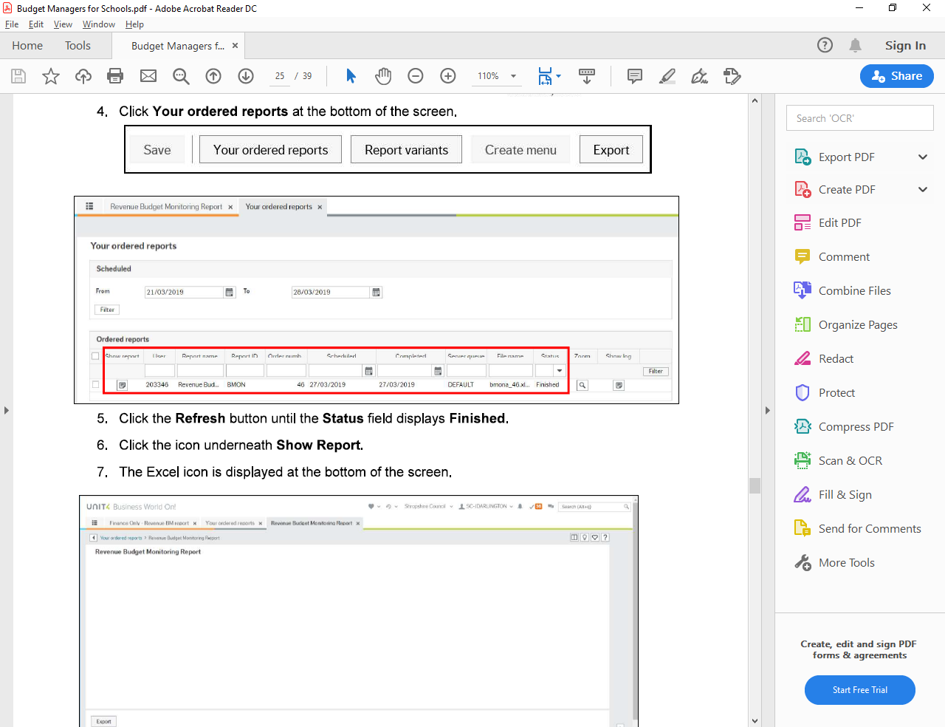

You may need to click on refresh button on the bottom left until the status displays Finished

Click the icon underneath show report. This will allow you to open the report in excel.

The excel report has two main tabs:

BMR tab

This tab displays details of all cost centres positions up to the previous full period.

The column headings are:
- Account Code – these are grouped by CFR headings
- Account Code description
- Analysis - to group costs further for example staffing costs by teachers/ supply etc.
- Previous Year Outturn
- Original Budget / Virements / Current Budget – these are grouped- these can be ungrouped by clicked the plus symbol.

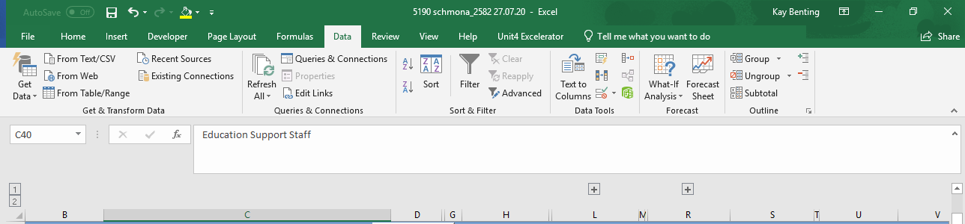
.
You will need to unprotect the spreadsheet first – Review – Unprotect Sheet

- Actuals/Purchase Orders/Goods Received/Registered Invoices/Revised Actuals – again these are grouped and can be opened up using the plus symbol,
- Budget Remaining – this balance includes the purchase orders/ goods received etc.

The remaining columns (with green headings) are for forecasting- see Budget Manager for Schools manual for more details of how to use this section. Your schools finance officer can post back your forecast on request and this will then be viewable on your BMR report in column U and/or column V.

Payroll tab

This tab shows details of payroll costs. These are sorted by CFR Analysis Group.

The first section gives details of the post and employee, including post hours and how many hours the employee is working at the time of running the report. It also details account codes, CFR codes and Anaysis.

The costs that have gone through in each month are to the right– click on the plus on the left-hand side to open details such as sickness pay or additional hours payments.

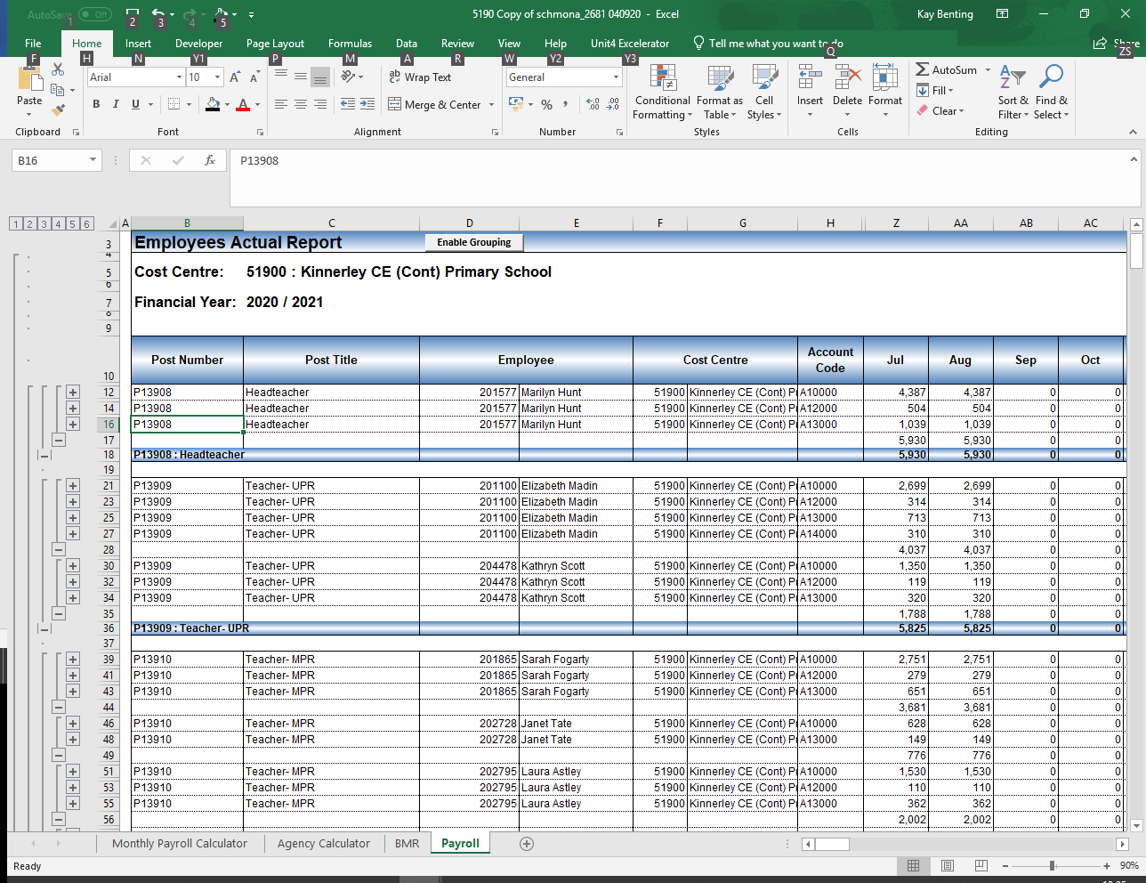

You may find that the Payroll report is useful to provide proof of financial loss to accompany a claim for staff absence insurance reimbursement.

The remaining columns are for forecasting- see Budget Manager for Schools manual for more details of how to use this section.

If you require assistance with any reports, please contact your School Finance Officer. Please also refer to our pages on the SLG here –
SchoolFinance

Other Housekeeping Duties
Business World Unit 4 ERP Guide - How do I Cancel / Close an Order on Business World?
Cancelling / Closing an order will remove any items that appear in your Outstanding Orders and Outstanding Goods Receipts Report.
Reports>Finance&Procurement>Finance>Budget Monitoring & I&Es>Orders / Requisitions> Outstanding Orders
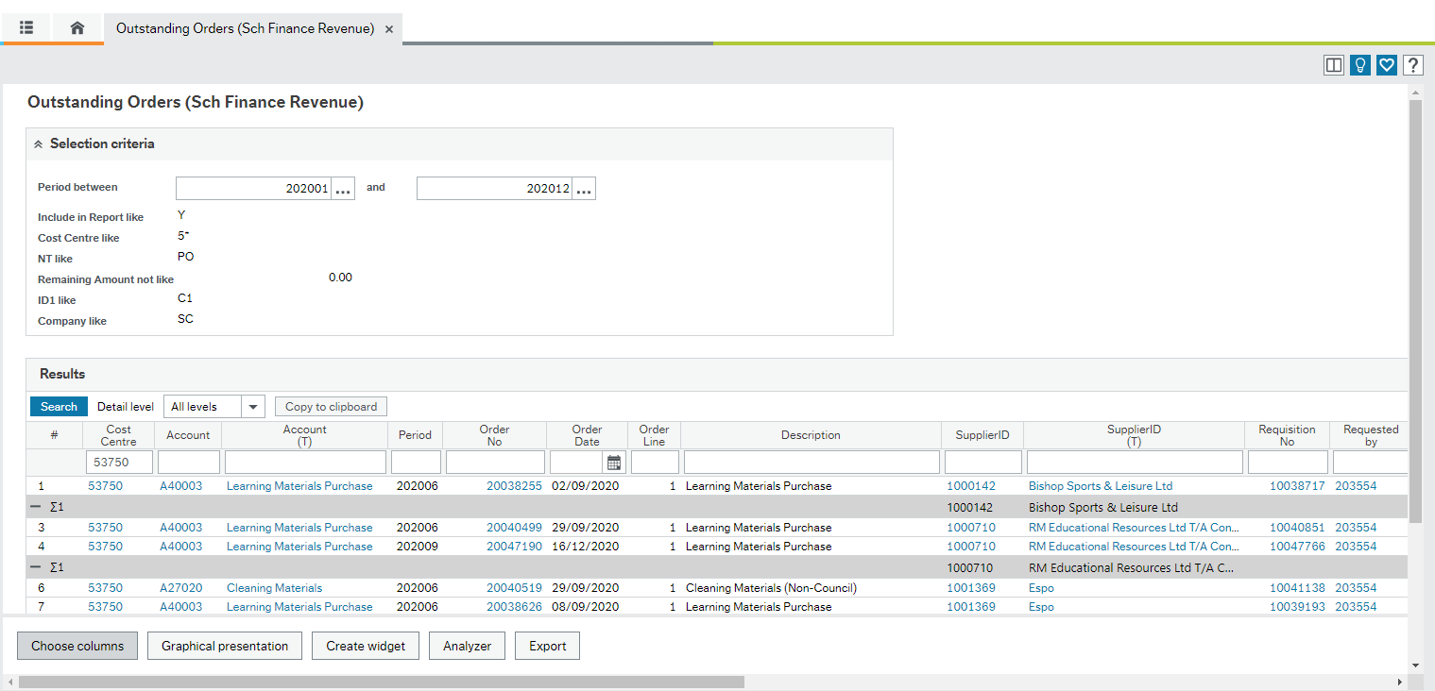
Reports>Finance&Procurement>Finance>Budget Monitoring & I&Es>Orders / Requisitions> Outstanding Goods Receipts
To Cancel / Close an order, you can go to Procurement > Purchase Orders > Purchase Order Follow Up > Purchase Order Amendment
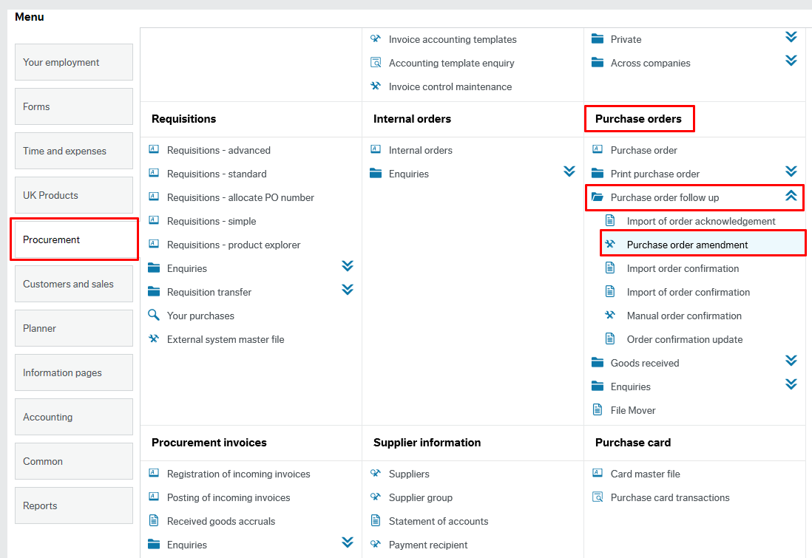
Next, you can type in the Purchase Order number (this number will begin with a 2 and be eight digits long) that you want to cancel in the top left hand corner and press tab. This will bring up the order details.

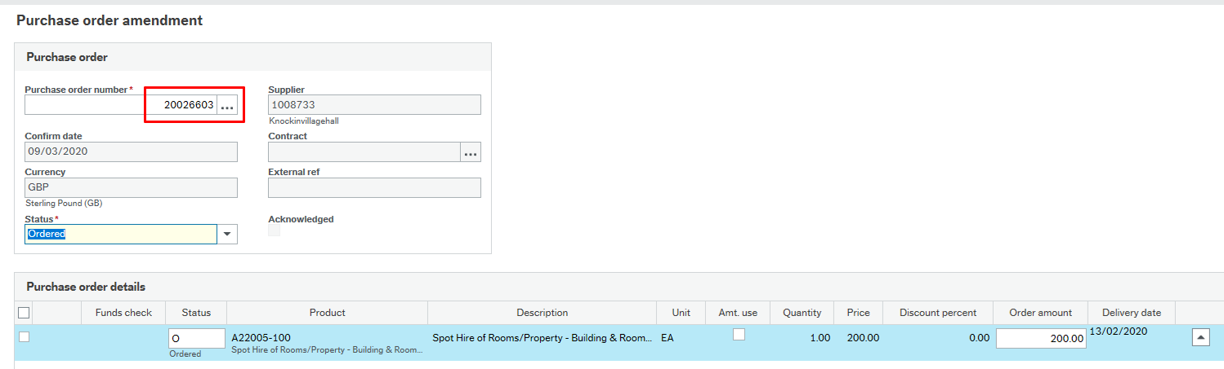

Following this, you can click on the Status dropdown and select the Closed Status. A pop up will appear asking if you are sure you want to close the order line and you can select Yes. (To note, if there is more than one order line this pop up will appear for each one and you will have to select Yes for each one)
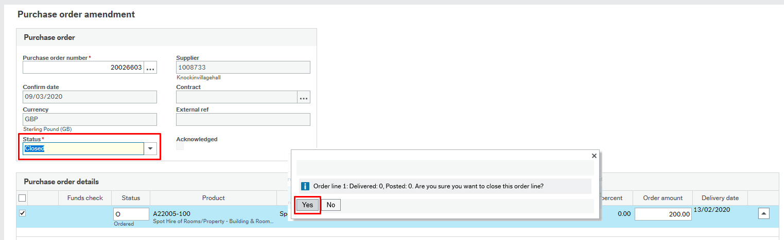
Finally, you will have to click on the Save button 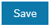 in the bottom left hand corner.
After Closing/Cancelling an order you will notice that the Order commitment will be removed from the outstanding orders report and will no longer appear as a purchase order commitment in the budget monitoring column the following day.

Troubleshooting Queries
-If you receive an error message saying that no person is showing as responsible for the order, you will have to contact erp@shropshire.gov.uk and quote the order number and ask them to add a specific authoriser to this order. Once business world have added the authoriser you will be able to close the order. If you are unsure who the authoriser should be you can use the Cost Centre Authoriser Enquiry found under Reports>Finance & Procurement>Finance
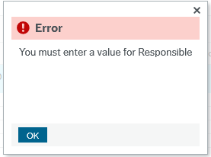

-If you receive an error message saying the Supplier is closed, you can contact the payments team on purchaseledger@shropshire.gov.uk or phone 01743 257910 to ask them to temporarily open the supplier so that the order can be closed.

Coding supply and additional hours;

A school has shared the following with us;

This is one of our PR28's with the names and resource numbers left off – see screen shot below.

In the 5th column, Supply Teacher category, you choose sickness or other, but this does not actually code it correctly. To do that you must enter E0202 (sickness) or E0201(other) in the Cat 5 Column – column 7.

In this column you can type in a different cost centre if that is where the cost should be charged to.

You can also use this CAT 5 column to categorise casual position extra hours to catering (E0601) or cleaning (E0401) or Lunchtime supervision (E0702) or the relevant Payroll group you want the cost to be charged to. In addition if for example someone with a Teaching Assistant position did a one-off lunchtime cover and was not set up with a lunchtime position number you could put code E0702 to ensure these hours are charged to the correct budget area;

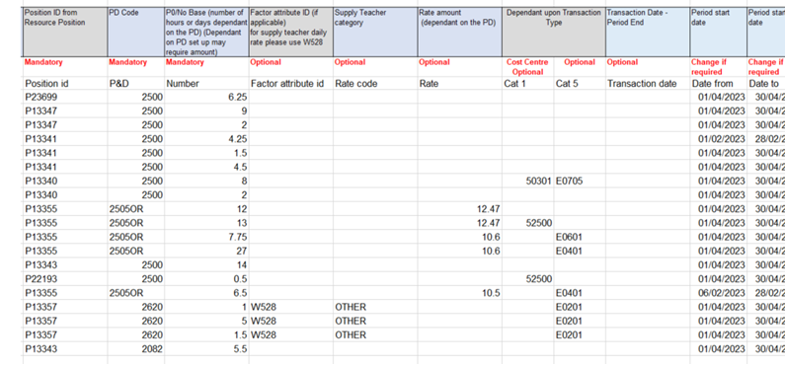

Splitting a Post between cost centres;

Fill out a Position Change Form on ERP – Forms/Organisation and Position.

The Form description would be what or whoever the change is for – for example - ‘Caretaker split at source.’

Type of Request – click on spacebar and pick Amend Position.

Supporting Comments – Fill in what you want to do – for example - Please can Employee number, Employee name and Post number’s contract for 40 hrs be split at source 50/25/25 between cost centres 5xxxx & 5xxxx & 5xxxx as of (start date you want costing split to begin.)

Politically Restrict post – No.

There isn’t anything else you need to complete on the form.

Then click Submit form.

It can take a while for it to be approved by HR.

Internal Recharge/Internal Invoice Account Code Guidance;

Internal Invoicing (Internal Recharge) | Shropshire Learning Gateway (shropshirelg.net)

Account codes starting with an R should be used for Traded Services. The credit account code for School’s income from internal services is R96404. The corresponding debit code for this credit account code must start with R4. When using R codes, the 4th digit on the income and 2nd digit on the expenditure must be the same – please select the relevant code from the latest Consistent Financial Reporting list saved in the link below;

IMPORTANT - THE SAME R/A ACCOUNT CODE PREFIX MUST BE USED ON BOTH SIDES OF THE IR, DEBIT AND CREDIT

Consistent Financial Reporting (CFR) | Shropshire Learning Gateway (shropshirelg.net)

For non-trading transfers between schools, account codes starting with an A can be used – see above list.

For apportionment of expenditure between federations, account codes starting with an A can also be used and without the need for an Internal Recharge form – Journals can be requested via your Schools Finance Officer. Federations may wish to set up an Inter school spreadsheet to record, review and approve shared federation costs which can be processed termly or when requested.

Please see common examples;
Example 1 - Trading;
CREDIT
R96404 School's income from internal services
DEBIT
R45025 IT Services & Consultancy Recharge
Example 2 – Transfer of Income;
CREDIT
R96507 – Payments received from other schools
DEBIT
R56160 – Schools Special facilities Recharge
Example 3 – Apportionment of cost;
CREDIT
A45015 IT Software Licences, Maintenance & Support or
R45015 IT Software Licences, Maintenance & Support Recharge (where original charge traded such as original charge from Shropshire Council)
DEBIT
A45015 IT Software Licences, Maintenance & Support
R45015 IT Software Licences, Maintenance & Support Recharge (where original charge traded such as original charge from Shropshire Council)
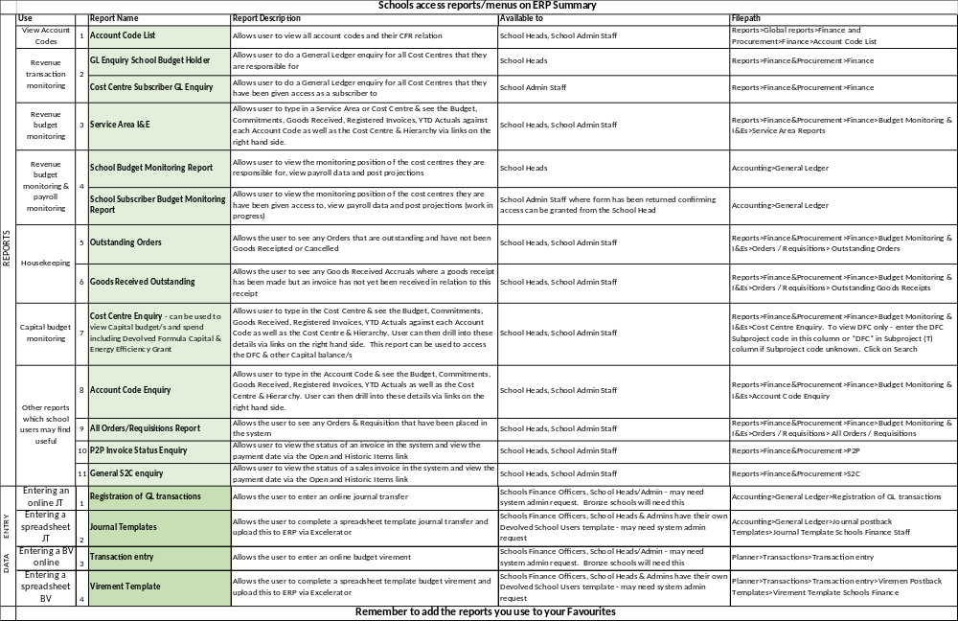

Glossary of Terms

Cost Centre Code The code allocated to your school to link costs to. It will be a 5-digit code starting with a 5. The cost centre code can indicate the school or a department/curriculum area within the school.

Account Code The code used to indicate the type of income or expenditure. These codes can be found on the CFR code list and Structure. For example, A10000 is Salary costs.

Analysis The code allows further grouping of costs for example E0101 = Teachers salary costs.

Journal Transfer (JT) Journal transfer is the movement of actual expenditure or income from one account code to another.

Budget Virement (BV) A budget virement is an allocation/movement of budget within account codes (not to be confused with a journal transfer.)

Consistent Financial A DFE requirement for a consistent framework of income and expenditure headings to allow schools
Reporting (CFR) to benchmark at a national level, promoting self-management and value for money.

CFR Code E Groups identify types of expenditure – a group of expenditure account codes report to each group.
I Groups identify types of income - a group of income account codes report to each group.

Period The first four digits relate the financial year and the final two to the months for example - 202001 = April 2020,
202012 = March 2021.

YTD Year to Date

TransNo The unique system reference number used when processing an invoice (to aid retrieval)

InvoiceNo The invoice reference/number

Useful Contacts

Schools Finance Team - education-finance@shropshire.gov.uk

Purchase Ledger Team - purchase-ledger@shropshire.gov.uk
One-off non-supplier payment - Sundrypayments@shropshire.gov.uk

If you have a system or access related query please email the system admin team erp@shropshire.gov.uk

For ERP Training - Katie.Dawson@Shropshire.gov.uk

Guidance & support can be found on the Shropshire Learning Gateway here and here

If your system query is urgent you can call: 01743 253030

Income Team - income@shropshire.gov.uk

Sales to Cash queries - salesledger@shropshire.gov.uk

Capital Project Monitoring and Devolved Formula Capital (DFC) queries please email michaela.probert@shropshire.gov.uk or Rachel.Nicholas@shropshire.gov.uk

Audit Team – audit@shropshire.gov.uk

Payroll Team - payroll.notifications@shropshire.gov.uk
• For Absence payments
• For Continuous service queries
• For Expenses queries
• For NI/Tax Code queries
• For general salary queries
• For Work schedules queries

Recruitment/starter/contract/establishment - Resourcing@shropshire.gov.uk

If you have a HR query: ask.HR@shropshire.gov.uk
• For Annual leave queries
• For contractual/policy queries

