**We are looking for people to become school governors**

   
  
 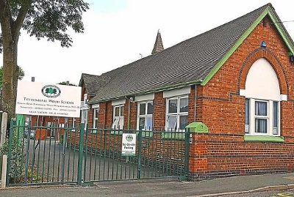

**BEING A GOVERNOR**

School governors are volunteers who work together as a governing board to provide the best education and care for children and young people. They have a single aim which is ‘school improvement’.

Governors are people from all walks of life. You can become a governor if you have:

• an interest in education;

• time, energy and enthusiasm;

• common sense;

• a willingness to accept responsibility;

• the ability to work and contribute in a team







**Who can become a school governor?**

You do not need to be an educational ‘expert’ or have any formal qualifications, in fact almost anyone over 18 can become a governor. An effective governing board has people drawn from different backgrounds and with a wide range of skills. There are a number of different categories of school governor, staff, parent and those from the community but all perform the same role.

**What is the role of a governor?**

The role of the school governors is to contribute to the work of the governing body in ensuring high standards of achievement for all pupils in the school through:

* Setting the school’s vision, ethos and strategic direction;
* Holding the headteacher to account for the educational performance of the school and its pupils and the performance of staff;
* Overseeing the financial performance of the school and making sure its money is well spent.

Headteachers are responsible for the day to day running of schools, including the management of staff, as professional leaders of the schools who are appointed by the governing body. Governors make decisions collectively on matters such as performance targets, school policies and development plans. They respond to Ofsted inspection recommendations and ensure the school’s achievements are reported to parents. Their role is strategic however may be involved in operational matters, with committees responsible for headteacher recruitment, parental appeals or complaints.

Governors spend about 6 hours each term attending governing body and committee meetings working together.

**What are the key activities of a governor?**

You would be involved in:

* actively participating in the work of the governing board by:
  + attending governing board and committee meetings (each at least once a term);
  + contributing to discussions;
  + taking part in agreed actions after meetings;
* getting to know the school and becoming familiar with it as a result of:
  + discussions with the headteacher and staff;
  + visiting to monitor the school;
  + taking part in school events;
  + reading and considering relevant information and reports.
* increasing your ability to contribute to the work of the governing board by taking part in training and other opportunities to develop knowledge, skills and understanding.
* seeking at all times to promote the best interests of the school and the education of its pupils.

**Why do people become governors?**

People may become school governors because they want to improve children’s life chances or/and wish to make a difference in the local community. On a personal level, it is an exciting opportunity to acquire or develop skills. Many companies encourage employees to become governors and allow time off with pay, although this is not a legal requirement. In any event, school governors are covered by the Employment Protection Act which grants employees reasonable unpaid time off for pubic duties.

**I am interested, so what do I do?**

If you are a parent of a pupil of school age, ask your child’s school about vacancies for parent governors. Alternatively, and for other governor categories, you can go online to the **Shropshire Governor Services website** at <http://www.shropshire.gov.uk/school-governors/how-do-i-become-a-school-governor/> to complete an application form to register interest in being a governor at a Shropshire school.

Governor Services can provide details of all governor vacancies in the county’s schools and further information on school governance:

**Contact: Governor Services: Tel: 01743 254361**





