**Where is My Payslip?**

Payslip – Your Employment – Personal Information and click on the blue paper clip

**My expenses hasn’t been included?**

Have you checked on the expenses experience pack to see if the items have been moved from DRAFT to In Progress or Completed?

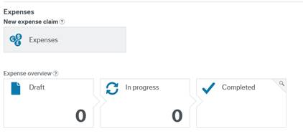

If this is still in progress then the claim has now been approved and may be still with your line manager for approval. This can be picked up in the next payment run.

**My overtime hasn’t been included?**

Its worth checking that the timesheets you have sent in have been changed from Draft to Ready and saved

Enter the timesheet module and check on the header

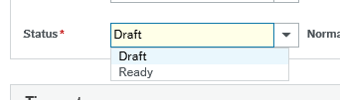

You can also check under Your timesheet details .

**Why has my Tax code changed?**

The personal allowance for Tax codes budget increase has been applied in April

**Why does my tax code begin with a ‘C’?**

A ‘C’ code will be applied to the Welsh Taxpayers Notice of coding when Welsh Income Tax becomes devolved from April 2019.

**Why has my National Insurance changed?**

The allowances for National Insurance changed from 1 April

**Why has my pension contribution changed?**

New pension bandings have been applied (where applicable) from 1 April