**We are looking for people to become school governors.**

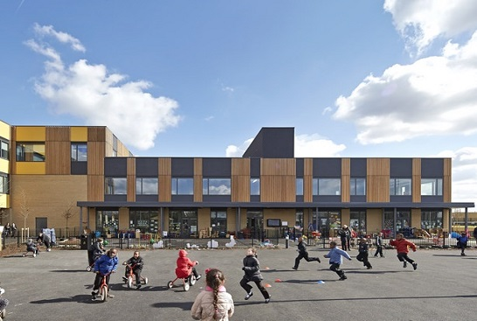   
  
 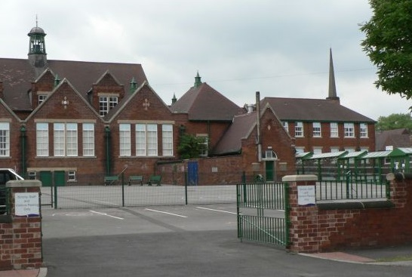

**Have you an interest in education?**

**Do you want to help provide the very best education and care for children and young people?**

School governors are volunteers who work together as a governing board. They have a single aim which is to harness their skills and abilities in a planned, determined manner to enable ‘school improvement’.

Governors are people from all walks of life who commit to approximately 2 meetings per term and occasional events. You can become a governor if you have:

• an interest in education;

• time, energy and enthusiasm;

• common sense;

• a willingness to accept responsibility and learn;

• the ability to work and contribute in a team.

**NO** prior knowledge is necessary as a comprehensive range of training and support is provided.

This is an opportunity to harness your skills and acquire new ones whilst making a real difference to the lives of children and young people.

**For further information on current vacancies at our school please contact:**

**Tel:   
Email:**





